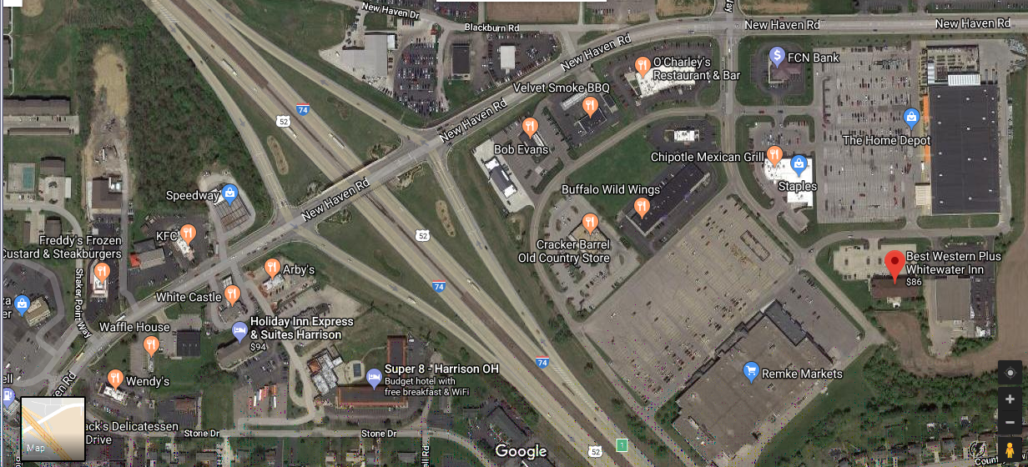
N
Hotel / Motel Information – Plus - at I-74 mile marker 1, Harrison, Ohio

I-74
mm 1
Harrison
OH

Road to Super 8
Motel is just past
the overpass by
the first gas station

Best Western
Plus Whitewater Inn
391 Comfort Drive
513-845-4970
$119 Double Beds

Holiday Inn Express
10906 New Haven Road
513-367-1111
$110ish Double Beds

Super 8 Harrison
10900 New Haven Road
513-202-4958
$70 Double Beds

El Mariachi Restaurant
10513 Harrison Ave
513-367-2204

Harrison Ave

Besides those listed on the Track’s Website, I’ve provided, in addition to the maps to the track, this map showing the intersection at I-74, mm 1, Harrison, Ohio, 6-miles west of the Track exit at mm 7, and include one good restaurant. Note that the Harrison Family Restaurant has sold and closed and removed from the map. As shown, note also that the service road to Super 8 is just past the south end of the New Haven Road overpass over I-74, past and between the east entry ramp and the gas station on that side – easy to miss if you are not looking for it.

