MAP TO EDGEWATER / 2019 Y-BLOCK NATIONALS

I-275 mm 36
@ US 27 ref.
N

I-74

I-71

To Columbus & Cleveland OH

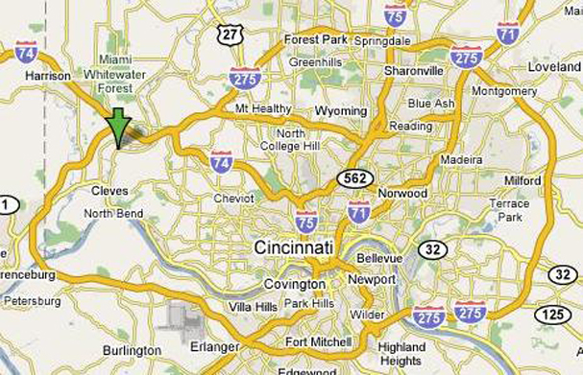
To Toledo OH

OH

I-74

To Indianapolis IN

IN

Lawrenceburg
I-275, mm 16
Airport

Cincy
Airport

KY

I-75 / I-71

---------------------------------------------------------------
To Louisville KY

|
Allgeier
Auto Parts

I-71

I-75

East Miami

River Road
|
|
To Lexington KY

-------------------------------------------------------------------_
|
Harrison OH , mm 1

Harrison Rd

Harrison Rd
|
I-74, mm 5
(I-275 mm 25)

Miamitown
1/2 Mile

East Miami

River Road

35 MPH
|

I-74

I-275

|

I-74 / I-275

|

IN

OHH

|
128
I-74, mm 7
Hamilton Cleves exit
I-74, mm 9
(I-275 mm 28)

I-275

|

I-74

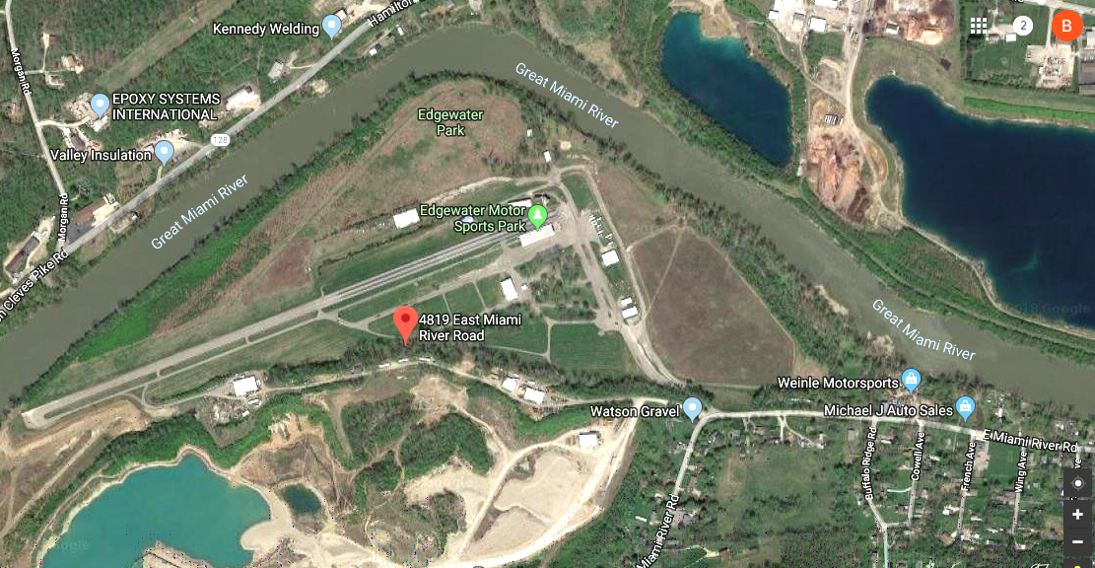
|

NOTE!

The 35 MPH Travel on

East Miami River Road
Is Heavily Monitored
the entire 3-miles
to the track – drive careful

Main Gates

128

I-275
to Lawrenceburg IN
mm 16

Road Gate opens early

CLOSE-UP OF THE TRACK (drawn roads not-to-scale)

